Multi-criteria evaluation of fall vegetation identifies optimized combinations of cover crop, tillage and residue managements

Virginia A. Nichols¹ Emma Randahl-Beltran¹ Marco Gentili¹ Mette Sønderskov¹, Simon Riley¹, Bo Melander¹

¹Department of Agroecology, Aarhus University, 1 Forsøgsvej, 4200 Slagelse, Denmark

Correspondance
Virginia A. Nichols
Email: gina.nichols@agro.au.dk

CRediT

Conceptualization – VN, BM
Data curation – VN, BM
Formal analysis – VN, ERB, MG
Funding acquisition – BM, MS
Methodology – VN, SR, BM
Project administration – BM, MS
Resources -
Supervision - BM
Validation - SR
Writing – original draft - VN
Writing – review and editing - ALL

Funding information
This research was funded by the European Union’s Horizon 2020 research and innovation program under grant agreement No. 727321 (project acronym, IWMPRAISE); we thank the funding body for its financial support.

Abstract (250 words max, currently at 243)
Off-season vegetation in agricultural fields may support positive environmental outcomes without compromising productivity. To test this, over three growing seasons in Denmark, we evaluated the ecological, environmental and agronomic performance of fall vegetation in a spring barley (Hordeum vulgare)–oat (Avena sativa)–faba bean (Vicia faba) sequence grown under thirty management systems combining cover crop, tillage, and straw managements. Five cover crop systems [grass/clover (Lolium perenne/Trifolium repens) mixtures sown early (MixE) and mid-season (MixM); radish (Raphanus sativus) sown mid-season (RadM) and post-harvest (RadL); no-cover control (NoCC)] were implemented in a long-term experiment with every combination of three tillage (no-till, surface, inversion) and two straw managements (retained, removed). Measured responses included cash crop yield, fall species cover and biomass, spring weed counts and pesticide use; ecological values of species and pesticide toxicity were estimated using published indices; total ‘utility’ was calculated using multi-criteria analysis. The study coincided with extreme weather years. All RadM systems had high crop yields, fall biomass, and fall ecological value, and did not increase perennial weeds. The presence of MixE reduced pesticide use (by necessity) but produced low-value plant communities with variable biomass. When paired with inversion tillage, MixE utility was higher than NoCC, but otherwise led to high perennial weed legacies and low crop yields. All implementations of MixM and RadL had similar utility to NoCC. Overall, RadM provided robust benefits in all contexts, but had highest utility in no-till with straw retention. Multi-criteria analysis suggested optimized cover crop choices for given management systems.

Keywords
Cover crops, tillage, cropping systems, weeds, radish, cover crop mixture, multicriteria evaluation

Highlights
- Evaluated fall vegetation in 30 cropping systems against six performance metrics
- Mid-season establishment of radish cover crop performed well in all metrics in all systems
- Cover crop mixtures did not establish well and produced low ecological value fall vegetation
- Cover crop systems did not always perform better than the no-cover control
- Crop volunteers dominated fall vegetation communities

1 INTRODUCTION
Modern phenomena such as population growth and climate change have led to significant declines in global biodiversity (Ceballos et al., 2017; Dirzo et al., 2014). Given that more than 40% of habitable land is used for agriculture (Ritchie & Roser, 2019), agricultural management plays a crucial role in shaping biodiversity levels (Burns et al., 2016; Gaba et al., 2020; Petit et al., 2011). Consequently, there is a growing need for agricultural systems that reconcile ecosystem health and biodiversity conservation with commercial production objectives (Henle et al., 2008; Labeyrie et al., 2021). In response, researchers are increasingly using more holistic assessments of plant communities (including weeds), including their potential ecological and environmental implications in tandem with agronomic impacts (Esposito et al., 2023; Petit et al., 2015; Storkey & Westbury, 2007; Yvoz et al., 2020).
As a corollary to an expanded view of the services non-crop plant communities can offer, there is potential in identifying spatial and temporal niches where plant communities can exist without detriment to production (Bensch et al., 2025; Blaix et al., 2018; Schatke et al., 2024). Fallow periods between cash crops may offer such an opportunity. In temperate agricultural systems that utilize tillage and/or herbicides, several studies have found that fall vegetation (cover crops, weeds) between cash crops has a minimal impact on subsequent spring crop weeds due to the strong filters exerted by spring tillage and/or spring herbicide application (Adeux et al., 2021, 2023; Leskovšek et al., 2025; Rouge et al., 2023). It follows that fall vegetation may present a unique opportunity for optimization. Using cover crops or weedy fallows may allow the expression of beneficial communities while minimizing the probability of future agronomic harm (Esposito et al., 2023). In this context, fall plant communities have the potential to offer a range of ecological supports and ecosystem services: the communities may serve as important promotors of plant diversity conservation (Fanfarillo & Kasperski, 2021), provide food sources for a high diversity of organisms (Balfour & Ratnieks, 2022; Marshall et al., 2003), reduce fall nitrate leaching (Miranda-Vélez et al., 2026; Sullivan et al., 2017), contribute to soil organic carbon (Jian et al., 2020), and mitigate soil erosion (Moreau et al., 2020).
Several factors can interact to shape fall vegetation characteristics in agro-ecosystems, including cover crops, tillage, and straw management. While previous studies have looked at these interactions, it is most often within the framework of reducing weeds (e.g.,(Shrestha et al., 2002; Swanton et al., 1999; Weber et al., 2017)). It is therefore unclear how these factors might be combined to optimize fall plant communities between cash crops for achieving multiple goals. In addition, while pesticides are a common tool used in agriculture, they have well-documented unintended, but negative consequences to the broader environment and society that are not often considered in field studies (Gandara et al., 2024; Rani et al., 2021; Sharma et al., 2019; Wan et al., 2025). Inclusion of these unintended impacts from pesticide use can contribute to a more comprehensive evaluation of cropping systems.
To better understand tradeoffs and potential for optimizing fall non-crop vegetation services, we utilized a long-term (>20 years) tillage and residue experimental platform to examine the impact of cover crop addition to different tillage/straw management combinations (Gómez-Muñoz et al., 2021). Yield of cash crops, soil coverage, fall biomass, plant community ecological value, presence of perennial weeds and pesticide toxicity were chosen as performance metrics to promote understanding of how cover cropping systems interact with tillage, residue removal, and weather in provision of various services and dis-services.
We hypothesized there would be tradeoffs between outcomes, with no single system offering the best performance in all desired areas, but that multi-criteria evaluation would highlight favorable combinations of practices.
We chose not to include the costs and labor associated with cover crop implementation due to the complexity and highly contextual nature of such estimates. For example, in Denmark, cover crop implementations may be mandatory depending on a given farm’s crop compositions and nutrient balance (Dalgaard et al., 2014), or may be required for receipt of subsidies that also vary by farm (Kathage et al., 2022), rendering the complexity of the actual cost calculations beyond the scope of this study. We also focused on short-term outcomes, as longer term changes in outcomes such as soil carbon accrual, changes in soil nitrogen status, and greenhouse gas emissions are difficult to evaluate robustly over short timeframes (Cusser et al., 2020; P. Smith, 2004).

2 MATERIALS AND METHODS

2.1 Field site
This study was conducted within a larger long-term experiment which was established in 2002 on a sandy loam at Flakkebjerg Research Centre, Denmark (latitude 55.317, longitude 11.400). Weather data for the present study was obtained from the Danish Meteorological Institute's (DMI) Open Data API for the Flakkebjerg station (55.322, 11.388), located less than 1 km from the trial (DMI, 2025). The 30-year average air temperature and precipitation for this site are 8.9 degrees Celsius and 589 mm, respectively. Averaged across the trial site, soil texture in the top 25 cm layer is 15% clay (<2 mm), 14% silt (2-20 mm), 43% fine sand (20-200 mm), and 28% coarse sand (200-2000 mm), with 1.2% organic carbon content (0-25 cm)(Scherner et al., 2016).
2.1.1 Study design
The long-term trial on which this experiment was superimposed is a split-split plot randomized complete block design with four replications. The trial includes cropping system as a treatment (Scherner et al., 2016), but for the present experiment plots from only two of those cropping systems were used, which only differed in residue management, so in this study, residue management (small grain straw retained, or removed) represented the main-plot treatment. Nested within residue management (two levels), the effective tillage (three levels) subplots were 5 meters wide and 40 m long (inversion tilled plots were 10 m wide to allow for a 2.5 m buffer on either side for soil displacement, but subplots were established within the middle 5 m). Each tillage subplot was divided into two columns with three micro-plots arranged within each column for a total of six micro-plots that were 2.5 m wide and 12.5 m long (see SM1 for a visual aid). One of the six micro plots was reserved for other sampling efforts, and a cover crop system treatment (five levels) was applied randomly to the remaining five micro-plots. In summary, this experiment included all combinations of two residue-managements, three tillage systems, and five cover crop systems for a total of 30 treatments replicated in four blocks. Treatments are described in more detail below.
2.1.2 Residue and tillage treatments
The same residue managements (small grain straw retained, removed) and categorical tillage system treatments [no tillage (NT), surface cultivation, inversion] have been in place since 2002. In the residue-removal treatments, straw was removed following harvest of small grain crops using a two-pass system wherein the straw was removed from the plots using a weed harrow. This resulted in removal of approximately 60% of the biomass (Hansen et al., 2015). In the residue-retained treatments, straw remained in the field following harvest.
While the overall tillage philosophies have remained the same since 2002, the exact machinery and timing of operations have varied (Scherner et al., 2016; Hansen et al., 2010). In the present experiment (2018-2020), plots under the inversion treatment were moldboard plowed to a depth of 20 cm in the late fall and seedbed harrowed to 3-4 cm depth in the spring before cash crop sowing; all crops were then sown with a traditional seed drill (Nordsten Lift-o-matic CLH300) with row spacings of 12.5 cm. In the late-sown radish cover crop treatment, plots were also harrowed to a depth of 3-4 cm after cash crop harvest to prepare the soil for sowing of the radish cover crop (see Table 1), while no post-harvest tillage was performed in the other cover crop treatments.
For the surface tillage system (non-inversion tillage), a Horsch Terrano 3 FX stubble tine cultivator was used to till to a depth 8-10 cm in the spring before cash crop sowing, and similarly harrowed (3-4 cm depth) only before the late-sown radish cover crop treatment but not before the other cover crop treatments. No tillage operations were performed in the NT treatment. In both the NT and surface tillage treatments, cash crops were sown with a chisel coulter (Horsch Airseeder CO 3) with row spacings of 17.5 cm for all crops (compared to 12.5 cm for the inversion treatment). Row spacings were different for the inversion treatment due to differences in the equipment representing typical production environments for each tillage system. Cash crop seeding rates were 20% higher in NT systems to compensate for poor establishment.
2.1.3 Cover crop treatments
Starting in the spring of the 2018 growing season, five cover crop treatments were randomly applied to the micro-plots (Table 1). The same micro-plot treatments were applied in 2018 and 2019 and were tracked until faba bean harvest in 2020. The sampling area for all measurements was located in the inner 1.5 m x 10 m area of the micro-plots.

Table 1. Summary of the five cover crop systems including an early-season sown mixture (MixE), a mixture (MixM) and forage radish (RadM) sown mid-season, forage radish sown late season (RadL), and a no-cover control (NoCC).
Cover crop treatment abbreviation | Seeding method and timing | Cover crop | Seeding rate
MixE | (Early-season) Sown 1 cm deep in between cash crop rows (12.5 cm or 17.5 cm, see section 2.1.2) shortly after cash crop sowing | Perennial ryegrass (grass; Lolium perenne) and red clover (clover; Trifolium pratense) | 3 kg ha⁻¹ grass + 8 kg ha⁻¹ clover
MixM | (Mid-season) Broadcast into standing crop approximately 14 days before expected cash crop harvest |  | 3 kg ha⁻¹ grass + 8 kg ha⁻¹ clover
RadM | (Mid-season) Broadcast into standing crop approx. 14 days before expected crop harvest | Fodder radish (Raphanus sativus) | 14 kg ha⁻¹
RadL | (Late season) Broadcast into the crop stubble after crop harvest | Fodder radish (Raphanus sativus) | 14 kg ha⁻¹
NoCC | - | None | -

2.1.4 Herbicides
Herbicide treatments reflected best practices using early spring visual surveys and a Danish online tool (Sønderskov et al., 2016), incorporating both the tillage and cover crop treatment considerations (Table 2). Each herbicide package is described in detail in supplemental material (SM1).

Table 2. Summary of trial’s herbicide applications; each herbicide package (HP) is described in detail in SM1; MixE: cover crop mixture sown shortly after cash crop sowing (see Table 1)
Year | Date of application | Cover crop treatment |  |  | Herbicide package
Year | Date of application | Inversion tillage treatment | Surface tillage treatment | No-till treatment | Herbicide package
2018  (spring barley, sown 19-Apr) | Before cash crop sowing  (10-Apr) | - | All | All | HP1
2018  (spring barley, sown 19-Apr) | After emergence (16-May) | MixE | MixE | MixE | HP3
2018  (spring barley, sown 19-Apr) | After emergence (16-May) | All except MixE | All except MixE | All except MixE | HP4
2018  (spring barley, sown 19-Apr) | In-season  (29-May) | All except MixE | All except MixE | All except MixE | HP5
2019  (spring oat, sown 4-Apr) | Before cash crop sowing  (1-Apr) | - | All | All | HP1
2019  (spring oat, sown 4-Apr) | After emergence (14-May) | MixE | MixE | MixE | HP3
2019  (spring oat, sown 4-Apr) | After emergence (14-May) | All except MixE | All except MixE | All except MixE | HP6
2020  (faba bean, sown 15-Apr) | Before cash crop sowing  (6-Apr) | - | All | All | HP2
2020  (faba bean, sown 15-Apr) | After emergence (6-May) | All | All | All | HP7
2020  (faba bean, sown 15-Apr) | In-season  (20-May) | All | All | All | HP7
2020  (faba bean, sown 15-Apr) | In-season  (2-Jun) | All | All | All | HP8

In the NT and surface tillage treatments, all plots were sprayed before cash crop sowing (Table 2). For the inversion tillage treatments, tillage provided weed control and therefore no herbicide was applied before cash crop sowing. For in-season weed control, herbicide packages applied in the MixE treatment had to accommodate the presence of the grass and clover crops and were therefore different from those applied in all other cover crop treatments. After emergence, weed surveys indicated a need to control Canada thistle [Cirsium arvense (L.) Scop.], and herbicide applications were chosen that are effective against this perennial weed. However, those same herbicides could not be used in the MixE plots, so the best available option was instead used with the intention of controlling the perennial weeds. Following faba bean sowing in 2020, all plots received the same herbicide treatments, with special consideration to control wild oat (Avena fatua L.).
2.1.5 General management
Spring barley (Hordeum vulgare L. v. Evergreen) was sown 19-Apr 2018 (300 plants m⁻²) and harvested 8-Aug 2018; spring oat (Avena sativa L. v. Poseidon) was sown on 4-Apr 2019 (300 plants m⁻²) and harvested 15-Aug 2019; faba beans (Vicia faba L. v. Boxer) was sown on 15-Apr 2020 (50 plants m⁻²) and harvested 24-Aug 2020. All plots received mineral fertilizer broadcast on spring barley plots on 17-Apr 2018 (126 kg N ha⁻¹, 24 kg P ha⁻¹ and 60 kg K ha⁻¹); on spring oat plots on 3-Apr 2019 (80 kg N ha⁻¹, 15 kg P ha⁻¹ and 38 kg K ha⁻¹ ); and on faba beans on 15-Apr 2020 (32 kg P ha⁻¹ and 80 kg K ha⁻¹). Herbicide application differed by treatment (see Table 2), but otherwise all plots were managed identically for diseases and insect pests according to the crop species grown and best management practices recommended by national advisory services.
The long-term experiment is rainfed, but in 2018 an exception was made due to an extremely hot and dry early growing season. In order to maintain the long-term viability of the experiment, all plots were irrigated with 25 mm in early June to ensure the establishment of all treatments. Irrigation was done with sprinklers mounted on a boom that was dragged through the experiment. This was also done on production fields in Denmark with access to irrigation structure, and therefore represents realistic production management.

2.2 Measurements
2.2.1 Crop yields
The middle area (net size 1.5 m x 10 m) of each micro-plot was harvested for grain yield with a plot combiner. Dry matter content was determined by a near-infrared spectroscopy analyzer [InfraTec™ 1241 Grain Analyzer, Foss A/S; (Büchmann et al., 2001)]). Grain yields are reported on a dry matter basis.
2.2.2 Fall and spring vegetation
Three categories of vegetation measurements were taken (Table 3).
Table 3. Summary of vegetation measurements collected 2018-2020, cover crop species are bolded
Measurement | Levels of measurement resolution
Fall ground cover composition (%) | Bare soil  Species (AVESA*, CAPBP, CIRAR, EPHEX, HORVW, LOLPE, MATIN, PAPRH, RAPSR, TAROF, TRFRE)  Genus (GERSS, LAMSS, SENSS, VERSS)
Fall biomass (g m-2) | Cover crop  Cash crop volunteer**  Other (all other biomass)
Spring weed counts (number m⁻²) | CIRAR  EQUAR  Dicot  Monocot
*EPPO code, see SM1 for Latin names
**Only collected in 2018

Ground cover composition was estimated from digital images taken in the fall (9-Nov 2018 and 1-Nov 2019) as done in (Melander et al., 2013). A 0.5 m² quadrat was placed in the plot, and an image was taken from a height of 1 m above the center of the quadrat. Three images were taken in each plot, meaning 10% of the micro-plot area was sampled (1.5 m² per 15 m² plot). Each image was subsequently overlaid with a grid consisting of 17 vertical and 17 horizontal lines, resulting in 289 intersections per image (SM1). Each intersection was classified as a soil or plant. Plant intersections were further classified to the species (12) or genus (4) level (Table 3). Percent coverage of each type was then calculated by dividing the number of touched intersections in that category by 289 intersections. For categorical analyses of percent cover, each species/genus was classified as ‘cover crop’, ‘weed’, ‘volunteer’ or ‘other.’ Species/genus coverages were assessed (not including soil as a coverage category) for evenness by dividing Shannon’s diversity index by the natural log of species richness (Pielou, 1966).
The amount of aboveground vegetative biomass in each treatment was measured shortly after image collection (15-Nov 2018 and 13-Nov 2019, respectively). Two 0.5 m² quadrats were randomly placed in each plot, and all aboveground biomass was cut at ground level and removed. The biomass samples from the two quadrats were separated into three fractions: cover crops, volunteers, and weeds in 2018. In 2019, biomass was only separated into two fractions (cover crops and other, the latter of which included both weeds and volunteers). Therefore, the categories ‘cover crop’ and ‘other’ were used for all aboveground biomass statistics (Table 3). The biomass fractions were dried in the oven at 80ºC for 24 hours and weighed. Dry biomass for each category was converted to grams per m².
The flora emerging in spring in the experimental plots was assessed on 22-May 2019 and 27-May 2020 after post-emergence weed control but before weeds were visually affected by the herbicides. Four categories were counted in three randomly placed 0.25 m² quadrats per plot. The categories were dicots, monocots, Canada thistle (Cirsium arvense) and horsetail (Equisetum arvense), the latter two being problematic perennial weeds in Denmark (Andreasen & Streibig, 2011; Salonen et al., 2008). The spring counts were made to record whether there were any traceable effects from previous year’s cover crop treatments, with the goal of assessing whether the previous fall vegetation resulted in detectable carry-over effects.
2.2.3 Quantification of plant community ecological value
While direct measurements of benefits are the most reliable, such measurements are not always available nor feasible. To enable more accessible accounting of benefits, several methodologies for estimating the potential values and/or services as well as potential harms of agricultural plant communities have been proposed (Gentili et al., in review). For this study, potential ecological value was estimated using a methodology and database from Yvoz et al. 2021. The fall vegetation produced blooms (SM1), so both pollinator value and ecological food web support were considered. Details on this calculation are presented in supplementary material, but a high level description is provided below.
The first component, potential benefits to pollinators, was comprised of three sub-indices representing (1a) the absolute benefit to honey and mason bees (Apis and Osmia species), (1b) bumble bees (Bombus species), and (1c) hoverflies (various species). The second, potential benefits to food webs, was comprised of three sub-indices representing (2a) absolute contributions to farmland birds, (2b) carabids, and (2c) parasitic wasps through provision of biomass and seeds. Organ level attributes reported by Yvoz et al. 2021 for 155 plant species were used to assign sub-index values. Out of the 11 species in our study, six had exact matches in their database (CAPBP, CIRAR, EPHEX, PAPRH, TAROF, TRFRE). For the other species and genus (Table 3), the mean values for all species within the matching database genus were used. The volunteer crops (barley, oats) did not have values in the database. Cereals are sown on 50% of Denmark’s agricultural land, totalling 1.3M hectares (Statistics Denmark, 2025). The cereal crop volunteers were therefore assigned no ecological value based on an assumption of ‘additional value saturation’ (Bensch et al., 2025), which presumes that the additional value of these plants in the landscape is minimal given the prevalence of winter cereal fields in Denmark. For comparison, the Brassicaceae winter rapeseed (Brassica napus subsp. Napus) is sown on approximately 0.2M hectares (7% of agricultural land), so while the fodder radish cover crop is also in the Brassicaceae family, it (and all other species/genuses) were assumed to contribute to additional ecological value on the landscape as assigned by the database. The sensitivity of results to this assumption was tested by excluding the value of fodder radish in the calculations and the implications are discussed.
Each sub-index was reported in different units, so after each species/genus in the present study was assigned a value for each of the sub-indices, the sub-indices were scaled within the present study such that the maximum corresponded to a value of 1, and the minimum a value of 0. While this has the potential to exaggerate differences between values that are similar on an absolute scale, we observed at least one order of magnitude of variation in our dataset for each sub-index, suggesting the variation in sub-index values was meaningful (see SM1). Sub-indices were summed to provide an estimated service value for each of the 16 species/genus observed in our study. These service values were weighted by the species/genus percent cover for each sample to calculate the fall vegetation community’s potential ecological support (benefits to pollinators and contributions to organismal food webs).
2.2.4 Multi-criteria summaries
Each cropping system was evaluated using the following six metrics, utilizing proxies (in parentheses) when no direct measurement was possible:
- Cash crop yields
- Potential to cause future agronomic harm (perennial weed count in spring)
- Soil protection (percent soil cover)

- Potential plant community ecological value (published indices)
- Potential to reduce nitrate leaching (fall biomass)

- Potential pesticide toxicity loads (Danish pesticide loads representing toxicity to human health, ecotoxicity, and environmental persistence)

Herbicide use data was translated into potential toxicity loads using the Danish Pesticide Load (DPL) values (Kudsk et al., 2018), and the total DPL was summed over the three year study period for each of the 30 cropping systems.
To summarise the performance of each system in our six metrics, we used multi-criteria decision making scaling processes (Monat, 2009).
First, estimated marginal mean values for each cropping system were extracted from statistical models in the performance metric’s original units. In all metrics, a value of zero had a physical interpretation, so we scaled the performances by dividing by the maximum performance value observed (rather than subtracting the minimum value before scaling). This retained a meaningful zero interpretation and avoided exaggeration of small differences in absolute performances. This resulted in normalized values for all performances on a scale from 0 to 1.
When performance metrics represented a situation wherein a higher value is less desirable (e.g., perennial weed counts, pesticide loads), the performances were flipped by taking a value of one and subtracting the performance, creating a mirrored scale such that a value of one always represents the most desirable situation (zero perennial weeds, and no pesticide load).
As a baseline analysis, the total relative utility of each system was calculated by assuming equal weights for all metrics, summing the scaled performances together and dividing by six (the maximum utility possible). Additionally, we used four farmer typologies (Upadhaya et al., 2021) to assign each of the six metrics a unique weight to reflect each producer typology’s value systems (Table 4), and calculated a weighted relative utility for these four scenarios. The logic for each weight assignment is provided in supplemental material (SM1).
Table 4. Five weighting scenarios were applied to the multi-criteria evaluation of the 30 cropping systems
 | Scenario
Metric | Equal weights | Conservationist | Deliberative | Traditionalist | Productionist
Cash crop yield | 16.7% | 50% | 70% | 20% | 90%
Perennial weed legacies | 16.7% | 10% | 15% | 30% | 0%
Soil protection | 16.7% | 10% | 15% | 10% | 10%
Ecological support | 16.7% | 10% | 0% | 10% | 0%
Nitrate leaching reduction | 16.7% | 10% | 0% | 20% | 0%
Pesticide toxicity | 16.7% | 10% | 0% | 10% | 0%

2.4 Statistics
All statistics and figures were done using R version 4.3.3 (R Core Team, 2024) relying heavily on the tidyverse meta package (Wickham et al., 2019), and additional packages for data wrangling and visualization (Silge & Robinson, 2016; Wickham et al., 2025; Wickham & Bryan, 2023). Univariate statistical models were built using lme4 (Bates et al., 2015) or glmmTMB (Brooks et al., 2017), and the best fit was chosen based on inspection of residual plots and AIC criteria (Bozdogan, 1987). The best fitting model was summarised using emmeans (Lenth, 2024) and multcomp (Hothorn et al., 2002). Multivariate models were built and analysed using vegan (Oksanen et al., 2024). Specific analyses are described in detail in supporting information along with ANOVA tables and estimated marginal means tables supporting interpretation (SM2). All R code and data is available as part of the Github repository for this publication (available upon acceptance of the publication), and raw data is provided both as an R package and as supplementary files.

3 RESULTS
3.1 Weather and crop yields
The three years of production covered extreme conditions compared to 30-year averages; 2018 was the driest year of the past 30 years, and 2020 was the warmest. All production years started the season with more precipitation than average, but both 2018 (spring barley) and 2020 (faba bean) moved into drought conditions as the season progressed.

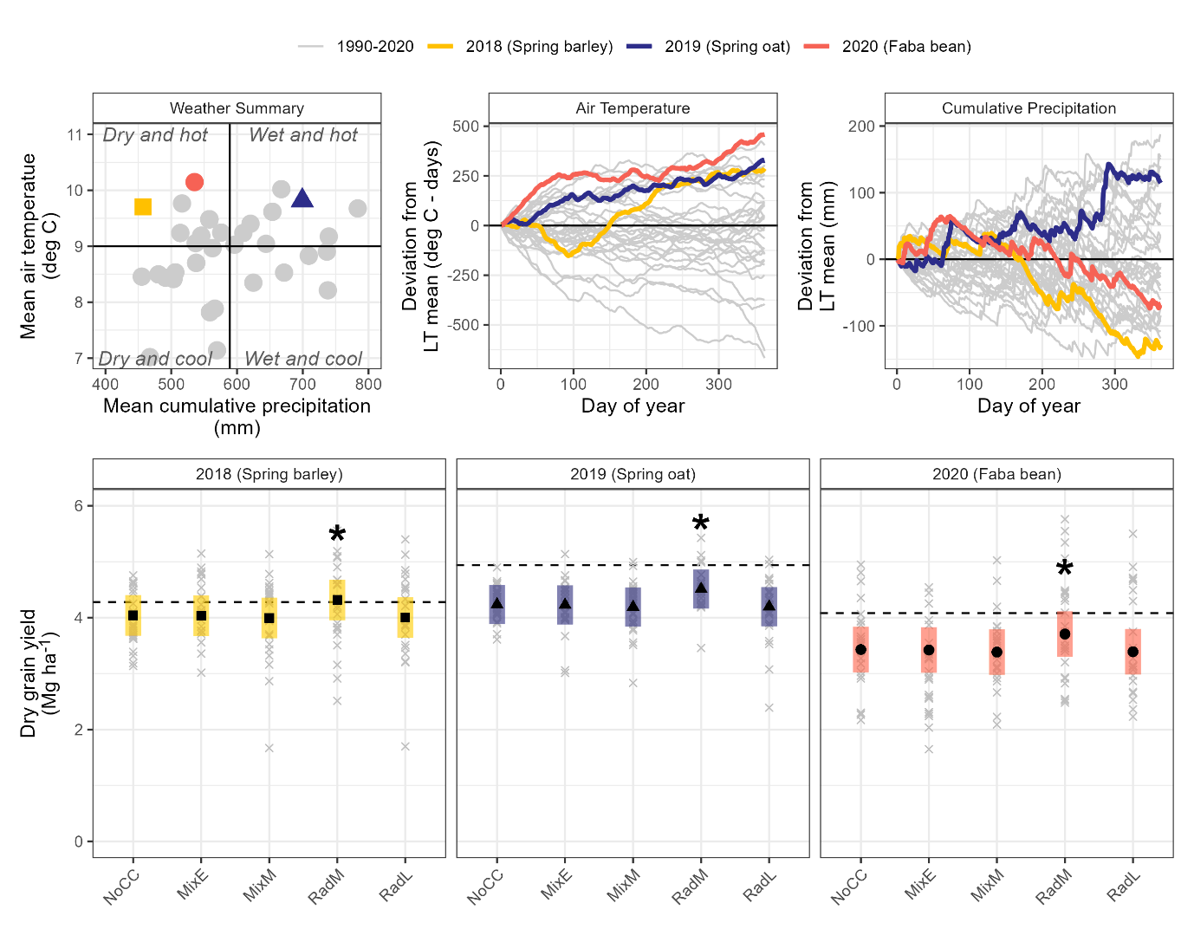

Figure 1. (Top) Weather summaries comparing study years (colored points and lines) to 30-year averages [long-term (LT) means, gray points and lines]. (Bottom) Yields (black points represent estimated marginal means with colored 95% confidence intervals, gray crosses are raw data) were comparable to mean yields observed in Denmark for each year (horizontal dashed lines) and within a crop year were significantly impacted only by cover crop treatment, with the mid-season sown radish (RadM) treatment producing significantly higher yields (asterisk) compared to the other cover crop treatments.

Yields varied significantly by the main effects of year (p<0.001) and cover crop treatment (p<0.001) with no interaction (SM2). In 2018, spring barley yields averaged 4.07 Mg ha⁻¹ in 2019 spring oat yields averaged 4.28 Mg ha⁻¹, and in 2020 faba bean yields averaged 3.47 Mg ha⁻¹ (Figure 1). On average, the RadM cover crop treatment exhibited 8% higher crop yields compared to all other cover crop treatments (p<0.001); the other cover crop treatments did not vary significantly from each other at a p=0.05 significance threshold (adjusted for multiple comparisons using the Tukey method). There was a significant interaction between tillage and year (p=0.02), which was driven by higher yields in the 2020 faba bean tilled treatment compared to the surface and NT treatments; crop yields did not vary by tillage treatment in any other year.
3.2 Fall vegetation
3.2.1 Biomass
The full statistical model predicting fall biomass showed complex interactions (SM2), but year explained the largest magnitude of variation (p<0.001). In 2018, average fall biomass production was 2.27 Mg ha⁻¹, more than twice the average in 2019 (0.99 Mg ha⁻¹; Figure 2). The effects of tillage were amplified in 2018 compared to 2019 (p<0.001). On average, biomass was highest in NT, and increasing tillage intensity significantly decreased fall biomass by 19% and 15% when moving from NT to surface, and surface to inversion, respectively. Cover crop treatments amplified the effects of tillage (p=0.048). Increases in biomass with less tillage were most pronounced in the RadM and RadL compared to other treatments; this pattern was consistent across years, with the NT combined with RadM offering the highest fall biomass in both years (Figure 2). Growing degree days accumulated from cover crop sowing to biomass sampling were not related to fall biomass values.

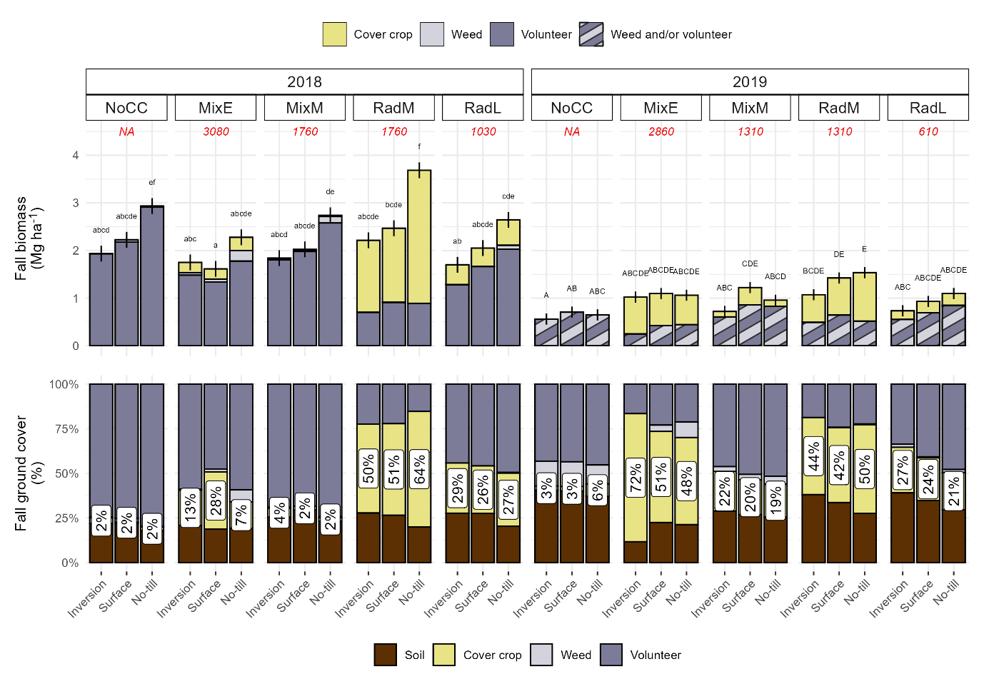

Figure 2 (Top) Fall biomass (estimated marginal means with 95% confidence intervals) was not related to growing degree days (GDDs, italic number in red) and exhibited complex treatment interactions (treatments within the same year not sharing a letter indicates significant differences), but the no-till mid-season sown radish (RadM) exhibited the highest biomass in all systems and years. (Bottom) Fall ground cover consisted mainly of cash crop volunteers, with cover crop coverage ranging from 2-72% (white labels) and exhibiting crossover interactions with year.

3.2.2 Cover
The percentage of the soil covered by vegetation exhibited complex interactions (SM2), but while this conveyed statistically significant differences in soil cover, differences of less than 5% coverage were not considered physically meaningful and are not discussed here.
Of the cover crop treatments, the NoCC vegetation coverage was the most impacted by the weather conditions (year; SM2), ranging from 80% soil coverage (CI: 76-83%) in 2018 to 61% (CI:56-66%) in 2019. The cover crop mixes offered stable coverage across years, at 83% (CI: 79-86%) and 74% (CI: 69-78%) soil coverage for MixE and MixM, respectively, while there was strong evidence (p<0.001) of moderate differences in soil coverage by radish cover crop treatments between years (mean of 75% and 67% coverage in 2018 and 2019, respectively) (SM2). Therefore, the use of a cover crop resulted in more stable soil coverage compared to no cover crop. Inversion tillage increased the soil coverage offered by the MixE (86%; CI:84-90%) compared to other tillage treatments (80%; CI:77-84%) but did not strongly impact the coverage in the other cover crop treatments (SM2).
Within the vegetative contribution to soil coverage, cash crop volunteers contributed the highest proportion of any vegetative category, averaging 61% of the vegetation cover, followed by cover crops (average of 35%) with weeds contributing an average of 4% to the total vegetation cover. The proportion of vegetation coverage offered by cover crops exhibited complex interactions which were mainly driven by the variability of MixE from year to year, and its larger proportion of cover crop contribution to soil coverage in inversion tillage compared to other tillages (SM2). In 2018 the MixE cover crops contributed a small amount of the total vegetation coverage [average of 14% (CI:12-17%)], while in 2019 they contributed over half the total vegetative cover [average of 57% (CI:52-62%; Figure 2)]. The proportion of vegetative coverage attributed to the RadM cover crop did not vary by year (p=0.80) and offered the highest average cover crop contribution of any treatment at 50% (CI:46-55%). Both MixM and RadL cover crop coverage was low to moderate (average of 8% and 25%, respectively), with moderate variability between years compared to the highly variable MixE and highly stable RadM.
3.2.3 Fall vegetation community
Cash crop volunteers were assigned a dummy code consistent across years to allow for more generalized inference of patterns across years. Cover crop treatment explained over half of the variance (SM2) and had a significant effect on community structure (p<0.001), with year explaining 8% of the variance, and tillage and residue management explaining less than 1% of the total variance each, respectively (SM2). The radish cover crop (RAPSR) drove the two radish treatments (RadM and RadL) communities, and the high RAPSR coverage in the RadM treatment rendered that coverage community completely distinct from the mixes and NoCC treatments (Figure 3). The MixE community had a higher presence of the grass/clover cover crop species, but shared many of the same species with the MixM and NoCC. The higher soil exposure in the NoCC and radish cover crop treatments (Figure 2) is also seen in the community assemblies.
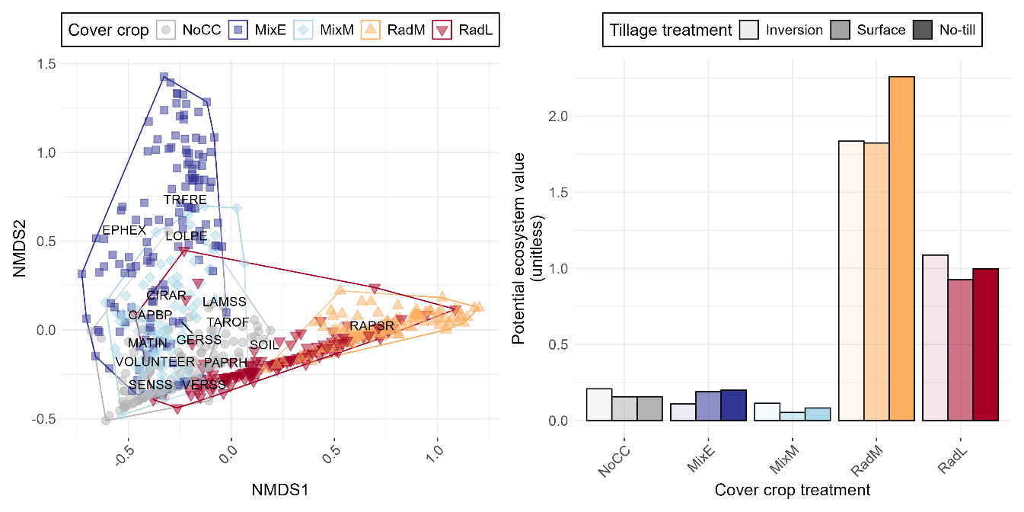

Figure 3 (Left) Non-metric multi-dimensional scaling (NMDS) analyses showed cover crop system had the largest impact on fall vegetation communities, with a minor impact of year, tillage system and residue removal. (Right) Radish cover crop systems (RadM, RadL) had the highest potential ecological value, with the mixes (MixE, MixM) and NoCC systems having similarly low ecological value, due to a high percent coverage of low value cash crop volunteers in the community (see Figure 2).

Radish species (RAPSS) were estimated to have the highest ecological value (SM1). The other cover crop species (LOLPE, TRFRE) had relatively low ecological value, while spring barley and spring oat volunteers had no value (SM1). This resulted in treatments with high percent radish (RAPSR) coverage exhibiting the highest potential ecological value (Figure 3). While the mixes’ communities contained species with high ecological value (e.g., TAROF, LAMSS) that were absent in the radish systems, these high-value species had small contributions to the percent coverage, and therefore did not result in high estimated ecological support potential. The value of the radish systems was driven by the RAPSR value – when this value was set to zero, radish system communities had very low ecological value (SM1).
Year and cover crop treatment had significant impacts on the number of species (see Table 3 for species list) observed in a community (p<0.001; SM2). The number of species observed in the raw data ranged from one to eight, with a mode of two in 2018 and three in 2019. The MixE had more species than the radish cover crops (p<0.001; SM2), but overall the number of species present was low in all communities. The modelled evenness of the communities ranged from 0.09 to 1 (the community had multiple species), and there was an amplifying interaction between cover crop treatment and year (p<0.001). Evenness was generally higher in the radish cover crop treatments because those communities were not dominated by the cash crop volunteers (Figure 2), followed by MixE, followed by MixM and NoCC treatments; this pattern was generally true regardless of tillage system, residue management, and year, although there were some minor but statistically significant impacts of residue removal on evenness (SM2).
3.3 Spring weed counts
Total spring weed counts ranged from 9-533 plants m⁻², with a median of 99 plants m⁻². There were complex treatment interactions, with a significant three-way interaction between year, tillage, and cover crop (p<0.001) and a significant two-way interaction between year and residue management (p<0.001; SM2). In 2019 retaining residue resulted in significantly more total weeds (p<0.0001), while in 2020 it had no impact. Residue did not interact with any other treatments. Within the NT system, MixE had significantly more weeds compared to all other cover crop treatments (1.5-1.7 times more, p<0.001). These differences were dampened in the surface tillage and disappeared in the inversion tillage systems (Figure 4). The elevated spring weed count in the MixE implemented in the NT system was significantly more pronounced in 2019 (2.6-3.7 times more weeds than other systems) compared to 2020 (1.6-1.7 times more weeds), but the patterns were the same. On average there were almost twice as many weeds in 2019 (mean:163, CI:118-157) compared to 2020 (mean:76, CI:66-88). Averaged across tillage systems, the total number of weeds was highest in the inversion tillage systems (mean:174 plants m⁻², CI:147-206), followed by surface tillage (mean:109 plants m⁻², CI:92-129), with the NT systems having the smallest number of total weeds (mean:55 plants m⁻², CI:46-66; Figure 4). This pattern was consistent in both years, but was again significantly magnified in 2019 (when there were more weeds).

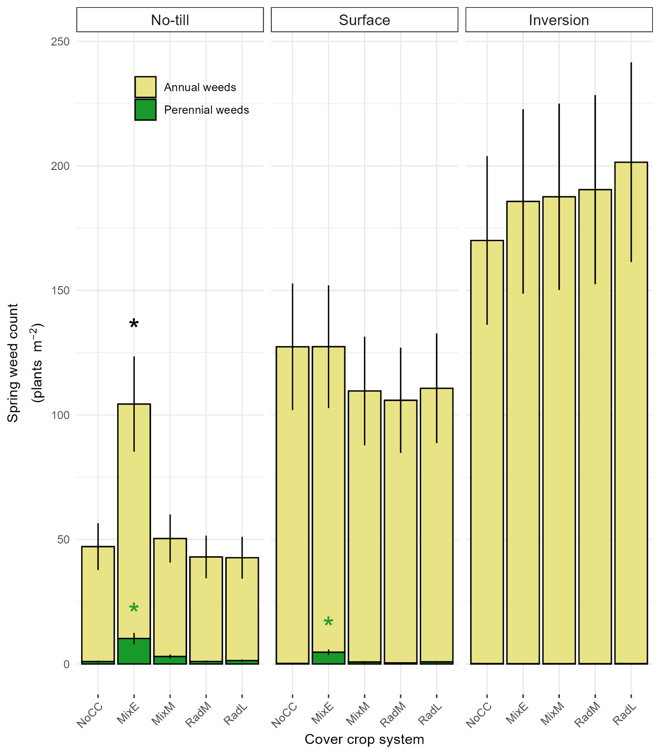

Figure 4. Marginal mean estimates averaged over years and straw management (bars) with standard errors of the means (vertical lines). There were no differences in total or perennial weed counts within the inversion tillage treatment, but in the no-till and surface tillage systems the early-sown mix (MixE) had significantly higher perennial weed counts, reflecting its different herbicide program compared to other cover crop systems (Table 2).

Despite having less total weeds, both NT and surface tillage had significantly increased numbers of perennial weeds compared to inversion tillage (SM2). The perennial weeds were mainly CIRAR (82%, versus 18% EQUAR). While the NoCC treatment averaged less than 1 perennial weed per m⁻², MixE averaged significantly more perennial weeds in the NT (10, CI:7-16) and surface tillage (5, CI:3-7) compared to other cover crop treatments, but did not differ in the inversion tillage. None of the other cover crop treatment’s perennial weed count differed from each other. Contrary to the total number of weeds, retaining straw resulted in a small but significant decrease in perennial weeds in 2019, but not in 2020 (SM2). In the last year of the trial, there was an inverse relationship between cash crop yields (faba bean) and perennial weeds, with more perennial weeds corresponding to lower yields, while there was no relationship with annual weeds (SM2).
3.3 Pesticide toxicity loads
Pesticide usage (and therefore pesticide toxicity loads) differed by year, tillage system, and cover crop system; straw retention had no impact on the system’s pesticide use. Inversion tillage had lower pesticide loads compared to NT and surface tillage, due to elimination of a pre-sowing herbicide application. In all systems and years, pesticide loads were lowest in the MixE treatments compared to the other cover crop treatments due to the different herbicide package required for post-emergence weed control when the grass/clover cover crop was present (SM1).
3.4 Multi-criteria summary
The system with the highest overall utility (assuming equal weighting for all metrics) was the radish cover crop sown mid-season (RadM) implemented in a NT system with residue retention (Figure 5), while the system with the lowest overall value was the mid-season sown mixture (MixM) implemented in a NT system with residue removal. Averaged across tillage and straw management systems, the RadM was the best performing cover crop treatment, and the MixM the worst. The early-sown mixture (MixE) performed well in the inversion tillage system, but poorly in the other tillage systems. There was almost no impact of residue management on the total value in the inversion tillage system, but residue retention increased total value in both the surface and NT systems, largely due to the suppression of perennial weeds.
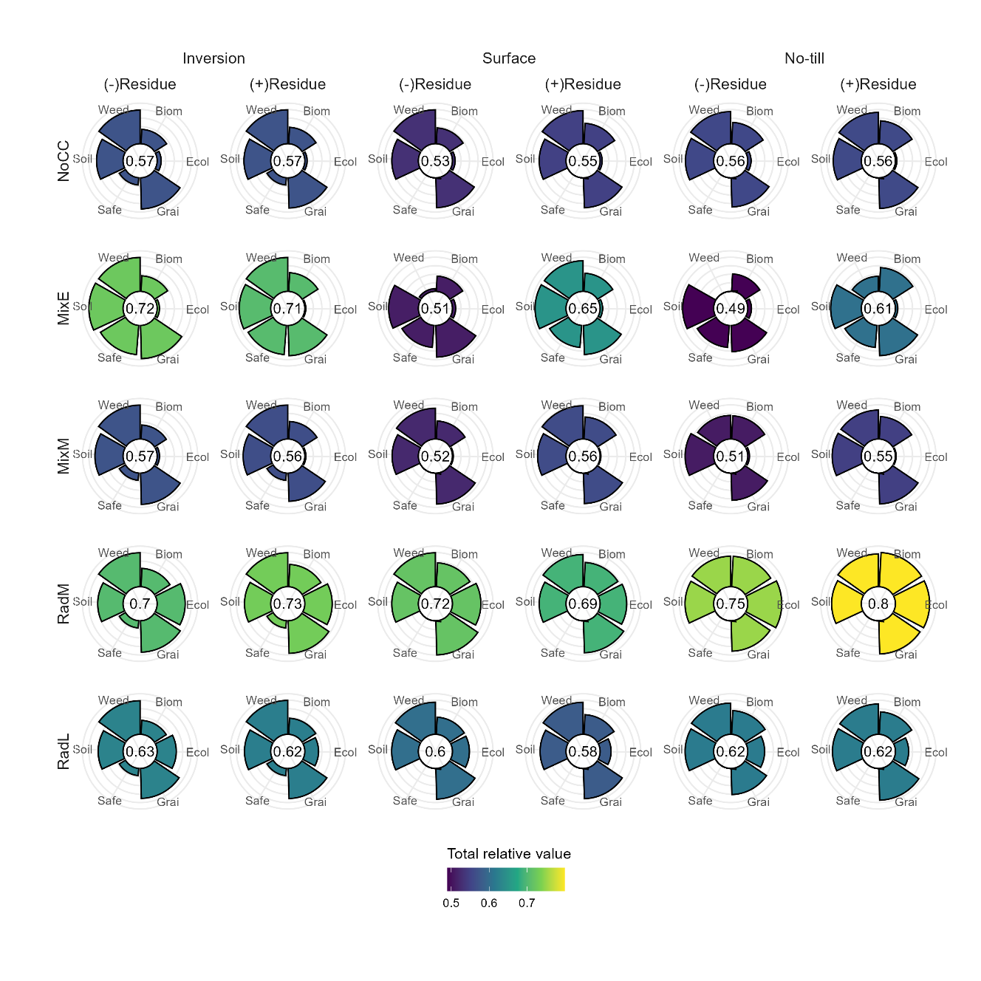
Figure 5. Summary of cropping systems’ performance in protecting soil (Soil), mitigation of fall nitrate leaching via fall biomass production (Biom), supporting ecological systems (Ecol), grain production (Grai), perennial weed suppression (Weed), and promoting human health and environmental safety (Safe); rows represent cover crop treatments, and columns represent tillage and residue managements.

4 DISCUSSION
4.1 Representativeness of results
The average grain yields in each year of the present study were lower than national averages for the same crops in the same years [4.3 Mg ha⁻¹ spring barley, 4.9 Mg ha⁻¹ oats, and 4.1 Mg ha⁻¹ faba bean, respectively (FAO, 2023)], but the maximum grain yields observed each year exceeded the national averages. The study results are therefore reasonably representative of production environments. While the study was only in place for three cash crop cycles, the weather years represented a range of conditions that provide a reasonable amount of inference space (Figure 1) wherein our results are informative.
4.2 Overall trends
Consistent with our hypothesis, no single system performed the best in all categories (Figure 5). The mid-season sown radish (RadM) exhibited both the highest overall value (in a NT system with residue retention) and highest average value across cropping systems and weather years. Climatically similar areas in Europe (Peel et al., 2007) have likewise found radish cover crop systems perform well in a variety of contexts (Elhakeem et al., 2023; Leskovšek et al., 2025). However, in our environment, sowing the radish cover crop before cash crop harvest (RadM) was necessary to achieve beneficial outcomes, as radish cover crops sown after crop harvest (RadL) had poorer overall performance, similar to the no-cover control. In Northern latitudes where available heat units reduce quickly following August cash crop harvests, it is likely important to establish even fast-growing cover crop species early in the season. Early sown mixes of slow-growing cover crops were sensitive to establishment conditions (Figure 2), but even in a well-performing year they did not produce as much biomass or soil coverage as the radish cover crop treatments. The competition posed early in the season by spring barley and spring oats, which are both valued for their competitive ability against weeds, may have suppressed the cover crop mixture growth (Pratt et al., 2023). In our study the cover crop mixtures only performed better than the no cover control when sown early, and in inversion tillage treatments. The early sowing restricted herbicide use, and when tillage was reduced this led to an increase in perennial weeds, which in turn led to lower crop yields. Retaining residue helped reduce perennial weeds in these low herbicide and reduced tillage systems. This adds to a growing body of research suggesting the use of cover crop mixes must be carefully and thoughtfully implemented, and the goals for the use of the mixes must be clearly articulated, as desirable outcomes are not guaranteed through diversity alone (Florence & McGuire, 2020; MacLaren et al., 2019; McKenzie-Gopsill et al., 2022; R. G. Smith et al., 2020). It also reiterates the well-known trade-off between herbicide use and tillage, showing elimination of both will likely lead to weed issues, but that residue retention in annual crop rotations may help alleviate perennial weed pressure in low input systems.
Of the management practices investigated, residue management (retention or removal) had the weakest impacts on the outcomes evaluated in this study. Particularly for small grains, straw management has been shown to have a more minor role in weed assemblages (Lacroix et al., 2024; Shi et al., 2026) and yields (Lu, 2020; Pittelkow et al., 2015) compared to factors like tillage. In our systems, these weak effects could be due to the incomplete removal of straw using a two-pass system wherein the straw is removed after grain has been harvested, resulting in around 60% of the straw being removed. However, in the long-term, residue management impacts soil function and biological activity (Gómez-Muñoz et al., 2021; Hansen et al., 2015; Thomopoulos et al., 2025), while also representing an income stream for producers, which would need to be accounted for in long-term perspective.
By using the utility values to rank the different cover crop systems within a tillage/residue combination, this complex information can be distilled into a digestible way (Figure 6).

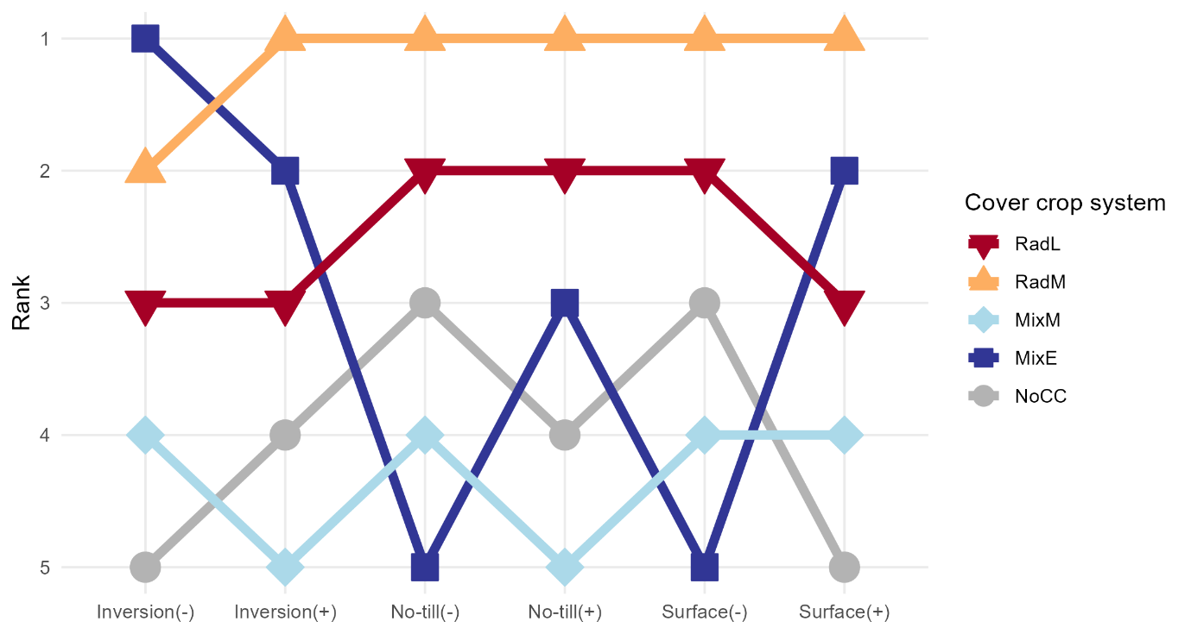

Figure 6. Rankings of the five cover crop systems (1 = highest utility, 5 = lowest) within a tillage and residue management combination; (+) = straw retained, (-) = straw removed

This presentation clearly shows the sensitivity of the MixE performance to the agronomic context in which it is deployed, and the consistency of the RadM performance across systems. While this representation exaggerates small differences in utility, it offers an accurate overall picture of the systems and their outcomes.
In this study we gave equal weight to each category – in reality these weights would differ according to farmer values and priorities, as well as policy and financial contexts. Utilizing different weightings to represent these different contexts could help identify systems best suited to certain farm ideotypes, or identify policy levers to promote certain outcomes (Upadhaya et al., 2021).
4.3 Fall community compositions
In our study, fall vegetation was mainly comprised of cash crop volunteers, which very effectively competed with weeds (Figure 2). Previous studies in similar climates have shown that fall communities dominated by cash crop volunteers reduce nitrate leaching compared to fallow land, suggesting cash crop volunteers are a significant source of fall biomass and therefore nitrogen sinks in these production environments; however, these studies also show radish cover cropping systems consistently exhibit higher biomass production compared to relying on crop volunteers and weeds (Elhakeem et al., 2023; Miranda-Vélez et al., 2026). The high ecological value of radish cover crops, coupled with this higher biomass production and concomitant reduction in nitrate leaching, suggests radish cover crops provides an effective and valuable displacement to volunteers and weeds (Figure 3) in the fall shoulder season. Our results support other studies that show radish cover crops produce high biomass that effectively competes with other vegetation (Brust et al., 2014; Lawley et al., 2012). While the other cover crop treatments supported more diverse fall communities, those communities had lower evenness than the radish treatments; the contributions of weed species to soil cover was small compared to the cash crop volunteers, resulting in small contributions to the potential ecological value of the communities. Therefore, in our study, weeds contributed very little biomass/coverage to the fall communities and were therefore not important to the ecological or environmental value provisions.
Our research suggests that while policies currently support radish cover crops for reducing fall nitrate leaching, they may also be promoting vegetation that provides value to ecosystems more broadly. However, the methods available for calculating potential ecological value are generalized and do not reflect local landscape compositions and ecologies, and more robust methods are needed to evaluate this hypothesis. Additionally, the potential for radish cover crops to provide winter bridges for disease and insect pest propagation requires consideration.
5 CONCLUSIONS
Through multicriteria analysis, we were able to highlight systems with good performance, while identifying areas for improvement. Mid-season planted radish performed reliably well across our performance metrics, but post-harvest planting significantly reduced the radish cover crop’s utility. The early planted cover crop mixture performed variably, but on average performed well in an inversion tillage system. While this analysis focused on short-term biophysical impacts and proxies, an analysis that includes more holistic and long-term outcomes coupled with producer-weighted values for each outcome would offer a more complete picture of system tradeoffs.

ACKNOWLEDGEMENTS

The authors acknowledge the contributions of Eugene Driessen and Karen Heinager who collected all data presented and whose field and laboratory expertise contributed significantly to this work.

CONFLICT OF INTEREST

Please state any conflicts of interest.

Supporting Information
REFERENCES
Adeux, G., Cordeau, S., Antichi, D., Carlesi, S., Mazzoncini, M., Munier-Jolain, N., & Bàrberi, P. (2021). Cover crops promote crop productivity but do not enhance weed management in tillage-based cropping systems. European Journal of Agronomy, 123, 126221. https://doi.org/10.1016/j.eja.2020.126221
Adeux, G., Rodriguez, A., Penato, C., Antichi, D., Carlesi, S., Sbrana, M., Bàrberi, P., & Cordeau, S. (2023). Long-term cover cropping in tillage-based systems filters weed community phenology: A seedbank analysis. Field Crops Research, 291, 108769. https://doi.org/10.1016/j.fcr.2022.108769
Andreasen, C., & Streibig, J. C. (2011). Evaluation of changes in weed flora in arable fields of Nordic countries – based on Danish long-term surveys. Weed Research, 51(3), 214–226. https://doi.org/10.1111/j.1365-3180.2010.00836.x
Balfour, N. J., & Ratnieks, F. L. W. (2022). The disproportionate value of ‘weeds’ to pollinators and biodiversity. Journal of Applied Ecology, 59(5), 1209–1218. https://doi.org/10.1111/1365-2664.14132
Bates, D., Mächler, M., Bolker, B., & Walker, S. (2015). Fitting Linear Mixed-Effects Models Using lme4. Journal of Statistical Software, 67(1), 1–48. https://doi.org/10.18637/jss.v067.i01
Bensch, J., de Mol, F., Gerowitt, B., & Zhang, H. (2025). Integrating Biodiversity Benefits of Weeds into the Economic Threshold Concept. Journal of Crop Health, 77(3), 96. https://doi.org/10.1007/s10343-025-01165-1
Blaix, C., Moonen, A. C., Dostatny, D. F., Izquierdo, J., Le Corff, J., Morrison, J., Von Redwitz, C., Schumacher, M., & Westerman, P. R. (2018). Quantification of regulating ecosystem services provided by weeds in annual cropping systems using a systematic map approach. Weed Research, 58(3), 151–164. https://doi.org/10.1111/wre.12303
Bozdogan, H. (1987). Model Selection and Akaike’s Information Criterion (AIC): The General Theory and its Analytical Extensions. Psychometrika, 52(3), 345–370. https://doi.org/10.1007/BF02294361
Brooks, M. E., Kristensen, K., Benthem, K. J. van, Magnusson, A., Berg, C. W., Nielsen, A., Skaug, H. J., Maechler, M., & Bolker, B. M. (2017). glmmTMB Balances Speed and Flexibility Among Packages for Zero-inflated Generalized Linear Mixed Modeling. The R Journal, 9(2), 378–400. https://doi.org/10.32614/RJ-2017-066
Brust, J., Claupein, W., & Gerhards, R. (2014). Growth and weed suppression ability of common and new cover crops in Germany. Crop Protection, 63, 1–8. https://doi.org/10.1016/j.cropro.2014.04.022
Büchmann, N. B., Josefsson, H., & Cowe, I. A. (2001). Performance of European Artificial Neural Network (ANN) Calibrations for Moisture and Protein in Cereals Using the Danish Near-Infrared Transmission (NIT) Network. Cereal Chemistry, 78(5), 572–577. https://doi.org/10.1094/CCHEM.2001.78.5.572
Burns, F., Eaton, M. A., Barlow, K. E., Beckmann, B. C., Brereton, T., Brooks, D. R., Brown, P. M. J., Fulaij, N. A., Gent, T., Henderson, I., Noble, D. G., Parsons, M., Powney, G. D., Roy, H. E., Stroh, P., Walker, K., Wilkinson, J. W., Wotton, S. R., & Gregory, R. D. (2016). Agricultural Management and Climatic Change Are the Major Drivers of Biodiversity Change in the UK. PLOS ONE, 11(3), e0151595. https://doi.org/10.1371/journal.pone.0151595
Ceballos, G., Ehrlich, P. R., & Dirzo, R. (2017). Biological annihilation via the ongoing sixth mass extinction signaled by vertebrate population losses and declines. Proceedings of the National Academy of Sciences, 114(30), E6089–E6096. https://doi.org/10.1073/pnas.1704949114
Cusser, S., Bahlai, C., Swinton, S. M., Robertson, G. P., & Haddad, N. M. (2020). Long-term research avoids spurious and misleading trends in sustainability attributes of no-till. Global Change Biology, 26(6), 3715–3725. https://doi.org/10.1111/gcb.15080
Dalgaard, T., Hansen, B., Hasler, B., Hertel, O., Hutchings, N. J., Jacobsen, B. H., Jensen, L. S., Kronvang, B., Olesen, J. E., Schjørring, J. K., Kristensen, I. S., Graversgaard, M., Termansen, M., & Vejre, H. (2014). Policies for agricultural nitrogen management—Trends, challenges and prospects for improved efficiency in Denmark. Environmental Research Letters, 9(11), 115002. https://doi.org/10.1088/1748-9326/9/11/115002
Dirzo, R., Young, H. S., Galetti, M., Ceballos, G., Isaac, N. J. B., & Collen, B. (2014). Defaunation in the Anthropocene. Science, 345(6195), 401–406. https://doi.org/10.1126/science.1251817
DMI. (2025). Denmark Meteorological Institute Open Data. https://www.dmi.dk/friedata/dokumentation/data
Elhakeem, A., Porre, R. J., Hoffland, E., Van Dam, J. C., Drost, S. M., & De Deyn, G. B. (2023). Radish-based cover crop mixtures mitigate leaching and increase availability of nitrogen to the cash crop. Field Crops Research, 292, 108803. https://doi.org/10.1016/j.fcr.2022.108803
Esposito, M., Westbrook, A. S., Maggio, A., Cirillo, V., & DiTommaso, A. (2023). Neutral weed communities: The intersection between crop productivity, biodiversity, and weed ecosystem services. Weed Science, 71(4), 301–311. https://doi.org/10.1017/wsc.2023.27
Fanfarillo, E., & Kasperski, A. (2021). An index of ecological value for European arable plant communities. Biodiversity and Conservation, 30(7), 2145–2164. https://doi.org/10.1007/s10531-021-02191-x
FAO. (2023). Crop and Livestock Products [Data set]. Food and Agriculture Organization of the United Nations. https://www.fao.org/faostat/en/#data/QCL
Florence, A. M., & McGuire, A. M. (2020). Do diverse cover crop mixtures perform better than monocultures? A systematic review. Agronomy Journal, 112(5), 3513–3534. https://doi.org/10.1002/agj2.20340
Gaba, S., Cheviron, N., Perrot, T., Piutti, S., Gautier, J.-L., & Bretagnolle, V. (2020). Weeds Enhance Multifunctionality in Arable Lands in South-West of France. Frontiers in Sustainable Food Systems, 4. https://doi.org/10.3389/fsufs.2020.00071
Gandara, L., Jacoby, R., Laurent, F., Spatuzzi, M., Vlachopoulos, N., Borst, N. O., Ekmen, G., Potel, C. M., Garrido-Rodriguez, M., Böhmert, A. L., Misunou, N., Bartmanski, B. J., Li, X. C., Kutra, D., Hériché, J.-K., Tischer, C., Zimmermann-Kogadeeva, M., Ingham, V. A., Savitski, M. M., … Crocker, J. (2024). Pervasive sublethal effects of agrochemicals on insects at environmentally relevant concentrations. Science, 386(6720), 446–453. https://doi.org/10.1126/science.ado0251
Gentili, M., Nichols, V., Jørgensen, J. R., Jørgensen, R. N., & Gislum, R. (in review). Functional Roles of Weeds in Arable Ecosystems: A Review of Methods to Assess Eco-system Services and Disservices. Weed Research.
Gómez-Muñoz, B., Jensen, L. S., Munkholm, L., Olesen, J. E., Møller Hansen, E., & Bruun, S. (2021). Long-term effect of tillage and straw retention in conservation agriculture systems on soil carbon storage. Soil Science Society of America Journal, 85(5), 1465–1478. https://doi.org/10.1002/saj2.20312
Hansen, E. M., Munkholm, L. J., Olesen, J. E., & Melander, B. (2015). Nitrate Leaching, Yields and Carbon Sequestration after Noninversion Tillage, Catch Crops, and Straw Retention. Journal of Environmental Quality, 44(3), 868–881. https://doi.org/10.2134/jeq2014.11.0482
Henle, K., Alard, D., Clitherow, J., Cobb, P., Firbank, L., Kull, T., McCracken, D., Moritz, R. F. A., Niemelä, J., Rebane, M., Wascher, D., Watt, A., & Young, J. (2008). Identifying and managing the conflicts between agriculture and biodiversity conservation in Europe–A review. Agriculture, Ecosystems & Environment, Special Section: Problems and Prospects of Grassland Agroecosystems in Western China, 124(1), 60–71. https://doi.org/10.1016/j.agee.2007.09.005
Hothorn, T., Bretz, F., & Westfall, P. (2002). multcomp: Simultaneous Inference in General Parametric Models (p. 1.4-30) [Data set]. https://doi.org/10.32614/CRAN.package.multcomp
Jian, J., Du, X., Reiter, M. S., & Stewart, R. D. (2020). A meta-analysis of global cropland soil carbon changes due to cover cropping. Soil Biology and Biochemistry, 143, 107735. https://doi.org/10.1016/j.soilbio.2020.107735
Kathage, J., Smit, B., Janssens, B., Haagsma, W., & Adrados, J. L. (2022). How much is policy driving the adoption of cover crops? Evidence from four EU regions. Land Use Policy, 116, 106016. https://doi.org/10.1016/j.landusepol.2022.106016
Kudsk, P., Jørgensen, L. N., & Ørum, J. E. (2018). Pesticide Load—A new Danish pesticide risk indicator with multiple applications. Land Use Policy, 70, 384–393. https://doi.org/10.1016/j.landusepol.2017.11.010
Labeyrie, V., Antona, M., Baudry, J., Bazile, D., Bodin, Ö., Caillon, S., Leclerc, C., Le Page, C., Louafi, S., Mariel, J., Massol, F., & Thomas, M. (2021). Networking agrobiodiversity management to foster biodiversity-based agriculture. A review. Agronomy for Sustainable Development, 41(1), 4. https://doi.org/10.1007/s13593-020-00662-z
Lacroix, C., Vandenberghe, C., Monty, A., & Dumont, B. (2024). Effect of long-term tillage and residue managements on weed flora and its impact on winter wheat development. Agriculture, Ecosystems & Environment, 366, 108937. https://doi.org/10.1016/j.agee.2024.108937
Lawley, Y. E., Teasdale, J. R., & Weil, R. R. (2012). The Mechanism for Weed Suppression by a Forage Radish Cover Crop. Agronomy Journal, 104(2), 205–214. https://doi.org/10.2134/agronj2011.0128
Lenth, R. V. (2024). emmeans: Estimated Marginal Means, aka Least-Squares Means. https://CRAN.R-project.org/package=emmeans
Leskovšek, R., Eler, K., & Zamljen, S. A. (2025). Weed suppression and maize yield influenced by cover crop mixture diversity and tillage. Agriculture, Ecosystems & Environment, 383, 109530. https://doi.org/10.1016/j.agee.2025.109530
Lu, X. (2020). A meta-analysis of the effects of crop residue return on crop yields and water use efficiency. PLOS ONE, 15(4), e0231740. https://doi.org/10.1371/journal.pone.0231740
MacLaren, C., Swanepoel, P., Bennett, J., Wright, J., & Dehnen-Schmutz, K. (2019). Cover crop biomass production is more important than diversity for weed suppression. Crop Science, 59(2), 733–748.
Marshall, E. J. P., Brown, V. K., Boatman, N. D., Lutman, P. J. W., Squire, G. R., & Ward, L. K. (2003). The role of weeds in supporting biological diversity within crop fields. Weed Research, 43(2), 77–89. https://doi.org/10.1046/j.1365-3180.2003.00326.x
McKenzie-Gopsill, A., Mills, A., MacDonald, A. N., & Wyand, S. (2022). The importance of species selection in cover crop mixture design. Weed Science, 70(4), 436–447. https://doi.org/10.1017/wsc.2022.28
Melander, B., Nørremark, M., & Kristensen, E. F. (2013). Combining mechanical rhizome removal and cover crops for Elytrigia repens control in organic barley systems. Weed Research, 53(6), 461–469. https://doi.org/10.1111/wre.12042
Miranda-Vélez, J. F., Simpson, G. L., Hansen, E. M., & Munkholm, L. J. (2026). In-season effects of winter cover crops and tillage on soil NO3- and N leaching – Analysis with generalized additive models. Agriculture, Ecosystems & Environment, 396, 110011. https://doi.org/10.1016/j.agee.2025.110011
Monat, J. P. (2009). The benefits of global scaling in multi-criteria decision analysis. Judgment and Decision Making, 4(6), 492–508. https://doi.org/10.1017/S1930297500004034
Moreau, D., Pointurier, O., Nicolardot, B., Villerd, J., & Colbach, N. (2020). In which cropping systems can residual weeds reduce nitrate leaching and soil erosion? European Journal of Agronomy, 119, 126015. https://doi.org/10.1016/j.eja.2020.126015
Oksanen, J., Simpson, G. L., Blanchet, F. G., Kindt, R., Legendre, P., Minchin, P. R., O’Hara, R. B., Solymos, P., Stevens, M. H. H., Szoecs, E., Wagner, H., Barbour, M., Bedward, M., Bolker, B., Borcard, D., Carvalho, G., Chirico, M., Caceres, M. D., Durand, S., … Weedon, J. (2024). vegan: Community Ecology Package. https://CRAN.R-project.org/package=vegan
Peel, M. C., Finlayson, B. L., & McMahon, T. A. (2007). Updated world map of the Köppen–Geiger climate classification. Hydrology and Earth System Sciences, 11(5), 1633–1644. https://doi.org/10.5194/hess-11-1633-2007
Petit, S., Boursault, A., Guilloux, M., Munier-Jolain, N., & Reboud, X. (2011). Weeds in agricultural landscapes. A review. Agronomy for Sustainable Development, 31(2), 309–317. https://doi.org/10.1051/agro/2010020
Petit, S., Munier-Jolain, N., Bretagnolle, V., Bockstaller, C., Gaba, S., Cordeau, S., Lechenet, M., Mézière, D., & Colbach, N. (2015). Ecological Intensification Through Pesticide Reduction: Weed Control, Weed Biodiversity and Sustainability in Arable Farming. Environmental Management, 56(5), 1078–1090. https://doi.org/10.1007/s00267-015-0554-5
Pielou, E. C. (1966). The measurement of diversity in different types of biological collections. Journal of Theoretical Biology, 13(1), 131–144. https://doi.org/10.1016/0022-5193(66)90013-0
Pittelkow, C. M., Liang, X., Linquist, B. A., van Groenigen, K. J., Lee, J., Lundy, M. E., van Gestel, N., Six, J., Venterea, R. T., & van Kessel, C. (2015). Productivity limits and potentials of the principles of conservation agriculture. Nature, 517(7534), 365–368. https://doi.org/10.1038/nature13809
Pratt, R. C., Schutte, B. J., Idowu, O. J., Uchanski, M., & Grant, L. (2023). Fall-sown small grain cover crops for weed suppression and soil moisture management in an irrigated organic agroecosystem. Renewable Agriculture and Food Systems, 38, e1. https://doi.org/10.1017/S174217052200028X
R Core Team. (2024). R: A Language and Environment for Statistical Computing. R Foundation for Statistical Computing. https://www.R-project.org/
Rani, L., Thapa, K., Kanojia, N., Sharma, N., Singh, S., Grewal, A. S., Srivastav, A. L., & Kaushal, J. (2021). An extensive review on the consequences of chemical pesticides on human health and environment. Journal of Cleaner Production, 283, 124657. https://doi.org/10.1016/j.jclepro.2020.124657
Ritchie, H., & Roser, M. (2019). Half of the world’s habitable land is used for agriculture. Our World in Data.
Rouge, A., Adeux, G., Busset, H., Hugard, R., Martin, J., Matejicek, A., Moreau, D., Guillemin, J.-P., & Cordeau, S. (2023). Carry-over effects of cover crops on weeds and crop productivity in no-till systems. Field Crops Research, 295, 108899. https://doi.org/10.1016/j.fcr.2023.108899
Salonen, J., Andersson, L., Andreasen, C., & Semb Torresen, K. (2008). Key perennial weeds in arable crops in the Nordic countries.
Schatke, M., Ulber, L., Musavi, T., Wäldchen, J., & von Redwitz, C. (2024). From unwanted to wanted: Blending functional weed traits into weed distribution maps. Weed Research, 64(6), 407–417. https://doi.org/10.1111/wre.12664
Scherner, A., Melander, B., & Kudsk, P. (2016). Vertical distribution and composition of weed seeds within the plough layer after eleven years of contrasting crop rotation and tillage schemes. Soil and Tillage Research, 161, 135–142. https://doi.org/10.1016/j.still.2016.04.005
Sharma, A., Kumar, V., Shahzad, B., Tanveer, M., Sidhu, G. P. S., Handa, N., Kohli, S. K., Yadav, P., Bali, A. S., Parihar, R. D., Dar, O. I., Singh, K., Jasrotia, S., Bakshi, P., Ramakrishnan, M., Kumar, S., Bhardwaj, R., & Thukral, A. K. (2019). Worldwide pesticide usage and its impacts on ecosystem. SN Applied Sciences, 1(11), 1446. https://doi.org/10.1007/s42452-019-1485-1
Shi, S., Yin, W., Niu, F., Yin, X., & Shi, Y. (2026). Sustainable agricultural practices shape the weed seed bank. A meta-analysis. Agronomy for Sustainable Development, 46(2), 18. https://doi.org/10.1007/s13593-026-01090-1
Shrestha, A., Knezevic, S. Z., Roy, R. C., Ball-Coelho, B. R., & Swanton, C. J. (2002). Effect of tillage, cover crop and crop rotation on the composition of weed flora in a sandy soil. Weed Research, 42(1), 76–87. https://doi.org/10.1046/j.1365-3180.2002.00264.x
Silge, J., & Robinson, D. (2016). tidytext: Text Mining and Analysis Using Tidy Data Principles in R. JOSS, 1(3). https://doi.org/10.21105/joss.00037
Smith, P. (2004). How long before a change in soil organic carbon can be detected? Global Change Biology, 10(11), 1878–1883. https://doi.org/10.1111/j.1365-2486.2004.00854.x
Smith, R. G., Warren, N. D., & Cordeau, S. (2020). Are cover crop mixtures better at suppressing weeds than cover crop monocultures? Weed Science, 68(2), 186–194. https://doi.org/10.1017/wsc.2020.12
Sønderskov, M., Rydahl, P., Bøjer, O. M., Jensen, J. E., & Kudsk, P. (2016). Crop Protection Online—Weeds: A Case Study for Agricultural Decision Support Systems. In J. Papathanasiou, N. Ploskas, & I. Linden (Eds.), Real-World Decision Support Systems: Case Studies (pp. 303–320). Springer International Publishing. https://doi.org/10.1007/978-3-319-43916-7_13
Statistics Denmark. (2025). Cropland. https://www.dst.dk/en/Statistik/emner/erhvervsliv/landbrug-gartneri-og-skovbrug/det-dyrkede-areal
Storkey, J., & Westbury, D. B. (2007). Managing arable weeds for biodiversity. Pest Management Science, 63(6), 517–523. https://doi.org/10.1002/ps.1375
Sullivan, C. A. O., Whisson, K., Treble, K., Roper, M. M., Micin, S. F., & Ward, P. R. (2017). Biological nitrification inhibition by weeds: Wild radish, brome grass, wild oats and annual ryegrass decrease nitrification rates in their rhizospheres. Crop and Pasture Science, 68(8), 798–804. https://doi.org/10.1071/CP17243
Swanton, C. J., Shrestha, A., Roy, R. C., Ball-Coelho, B. R., & Knezevic, S. Z. (1999). Effect of tillage systems, N, and cover crop on the composition of weed flora. Weed Science, 47(4), 454–461. https://doi.org/10.1017/S0043174500092079
Thomopoulos, S., Munkholm, L. J., Elsgaard, L., & Ravnskov, S. (2025). Tillage and residue management modulate the links between soil physical signatures and arbuscular mycorrhizal fungal biomarkers. Geoderma, 454, 117204. https://doi.org/10.1016/j.geoderma.2025.117204
Upadhaya, S., Arbuckle, J. G., & Schulte, L. A. (2021). Developing farmer typologies to inform conservation outreach in agricultural landscapes. Land Use Policy, 101, 105157. https://doi.org/10.1016/j.landusepol.2020.105157
Wan, N.-F., Fu, L., Dainese, M., Kiær, L. P., Hu, Y.-Q., Xin, F., Goulson, D., Woodcock, B. A., Vanbergen, A. J., Spurgeon, D. J., Shen, S., & Scherber, C. (2025). Pesticides have negative effects on non-target organisms. Nature Communications, 16(1), 1360. https://doi.org/10.1038/s41467-025-56732-x
Weber, J. F., Kunz, C., Peteinatos, G. G., Zikeli, S., & Gerhards, R. (2017). Weed Control Using Conventional Tillage, Reduced Tillage, No-Tillage, and Cover Crops in Organic Soybean. Agriculture, 7(5), 43. https://doi.org/10.3390/agriculture7050043
Wickham, H., Averick, M., Bryan, J., Chang, W., McGowan, L. D., François, R., Grolemund, G., Hayes, A., Henry, L., Hester, J., Kuhn, M., Pedersen, T. L., Miller, E., Bache, S. M., Müller, K., Ooms, J., Robinson, D., Seidel, D. P., Spinu, V., … Yutani, H. (2019). Welcome to the Tidyverse. Journal of Open Source Software, 4(43), 1686. https://doi.org/10.21105/joss.01686
Wickham, H., & Bryan, J. (2023). readxl: Read Excel Files. https://CRAN.R-project.org/package=readxl
Wickham, H., Pedersen, T. L., & Seidel, D. (2025). scales: Scale Functions for Visualization. https://CRAN.R-project.org/package=scales
Yvoz, S., Petit, S., Biju-Duval, L., & Cordeau, S. (2020). A framework to type crop management strategies within a production situation to improve the comprehension of weed communities. European Journal of Agronomy, 115, 126009. https://doi.org/10.1016/j.eja.2020.126009

